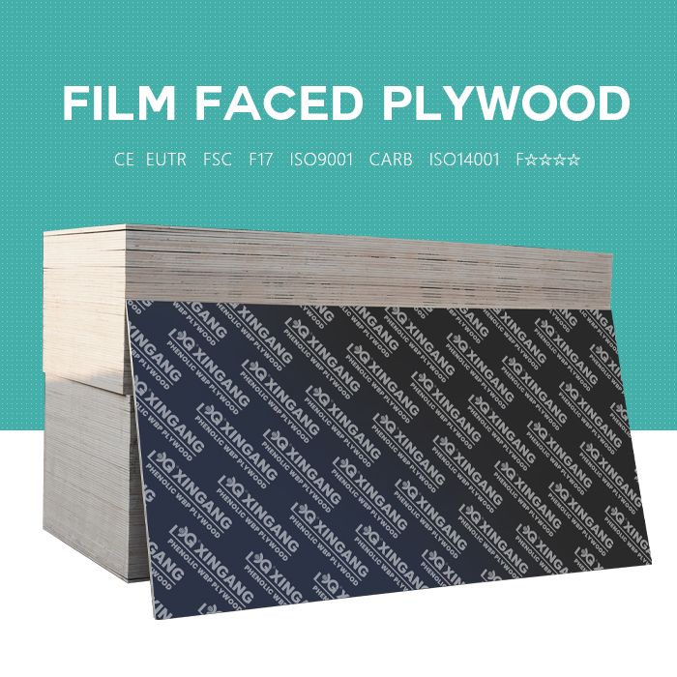
Size(mm) : 915x1830 / 1200x2400 / 1220x2440 / 1250x2500 / 1500x2500 / 1500x3000
Thickness(mm) : 6.5 / 9 / 12 / 15 / 18 / 20 / 21 / 24 / 27 / 30 / 35
Length&width tolerance : +/-2mm
Number of layers : from 5 up to 21 depending on thickness
Core : Poplar , Hardwood , Birch , Pine , Combi
Water resistance : WBP(weather and water-proof)

Inspected unit | SHANDONG XINGANG GROUP
Product name | Film faced plywood |  | No.of layers | 11
Product size | 2440×1220×18mm |  | Wood species | Eucalyptus
Testing date | 31th Mar,2021 |  | Standard | GB/T17656-2008
Glue | Phenolic |  | Sample size | mm:600×1200×18 2pcs
Testing item |  | Unit | Normal value required | Tested value | Conclusion
Moisture content |  | % | 2023/6/14 | 7.5 | PASS
Density |  | Kg/m3 | 580-620 | 605 | PASS
Bonding quality | Mear shear strength(fV) | N/mm2 | ≥0.70 | Xmax:1.71 | PASS
 |  |  |  | Xmin:1.06 | PASS
Bonding quality | Mean apparent percentage wood failure(W) | % | / | 70 | PASS
Bending strength | Longitudinal grain | N/mm2 | ≥35 | 70.12 | PASS
Bending strength | Cross grain | N/mm2 | ≥25 | 45.84 | PASS
Modulus of elasticity in bending | Longitudinal grain | N/mm2 | ≥5000 | 7250 | PASS
Modulus of elasticity in bending | Cross grain | N/mm2 | ≥4000 | 5270 | PASS
remarks | Moisture content (specimen dimension:50mm×50mm×18mm; number: 6)
remarks | density(specimen dimension:50mm×50mm×18mm; number: 6)
remarks | Bonding quality(specimen dimension: 100mm×25mm×18mm; 10 test pieces per glueline)
remarks | Bending strength and Modulus of elasticity in bending  (specimen dimension: 300mm×50mm×18mm; number: 6 with Longitudinal grain fibers and 6 with Cross grain fibers)

Sr  No. | Property |  | Unit | Test  Method | Value of  Test | Result
1. | Moisture Content |  | % | EN 322 | 7.8 | Check out
2. | Density |  | kg/m³ | EN 323 | 635 | Check out
3. | Bonding Quality | Bonding Quality | Mpa | EN 314 | Max：1.68  Min ：0.81 | Check out
3. | Bonding Quality | Damage Rate | % | —— | 85% | Check out
4. | Bending Modulus of  Elasticity | Longitudinal | Mpa | EN 310 | 6830 | Check out
4. | Bending Modulus of  Elasticity | Lateral | Mpa | EN 310 | 6090 | Check out
5. | Bending Strength  N/mm | Longitudinal | Mpa | EN 310 | 59 | Check out
5. | Bending Strength  N/mm | Lateral | Mpa | EN 310 | 43.9 | Check out
6. | Cycle Life | About 15-25 Repeated Using Times According to Projects by Formwork Application
Tested Item Type： full hardwood film faced plywood 18mm.

Tested Item Type： full poplar film faced plywood 18mm.
Sr  No. | Property |  | Unit | Test  Method | Value of  Test | Result
1. | Moisture Content |  | % | EN 322 | 8.4 | Check out
2. | Density |  | kg/m³ | EN 323 | 530 | Check out
3. | Bonding Quality | Bonding Quality | Mpa | EN 314 | Max：1.40  Min ：0.70 | Check out
3. | Bonding Quality | Damage Rate | % | —— | 74% | Check out
4. | Bending Modulus of  Elasticity | Longitudinal | Mpa | EN 310 | 5215 | Check out
4. | Bending Modulus of  Elasticity | Lateral | Mpa | EN 310 | 4796 | Check out
5. | Bending Strength  N/mm | Longitudinal | Mpa | EN 310 | 52.74 | Check out
5. | Bending Strength  N/mm | Lateral | Mpa | EN 310 | 43.55 | Check out
6. | Cycle Life | About 8-15 Repeated Using Times According to Projects by Formwork Application

Tested Item Type： full birch film faced plywood 18mm.
Sr  No. | Property |  | Unit | Test  Method | Value of  Test | Result
1. | Moisture Content |  | % | EN 322 | 8.1 | Check out
2. | Density |  | kg/m³ | EN 323 | 690 | Check out
3. | Bonding Quality | Bonding Quality | Mpa | EN 314 | Max：1.85  Min ：0.99 | Check out
3. | Bonding Quality | Damage Rate | % | —— | 94% | Check out
4. | Bending Modulus of  Elasticity | Longitudinal | Mpa | EN 310 | 9610 | Check out
4. | Bending Modulus of  Elasticity | Lateral | Mpa | EN 310 | 7360 | Check out
5. | Bending Strength  N/mm | Longitudinal | Mpa | EN 310 | 79 | Check out
5. | Bending Strength  N/mm | Lateral | Mpa | EN 310 | 77.3 | Check out
6. | Cycle Life | About 30-50 Repeated Using Times According to Projects by Formwork Application

COLOR OF SURFACE/FILM:BLACK FILM,BROWN FILM,GREEN PLASTIC FILM
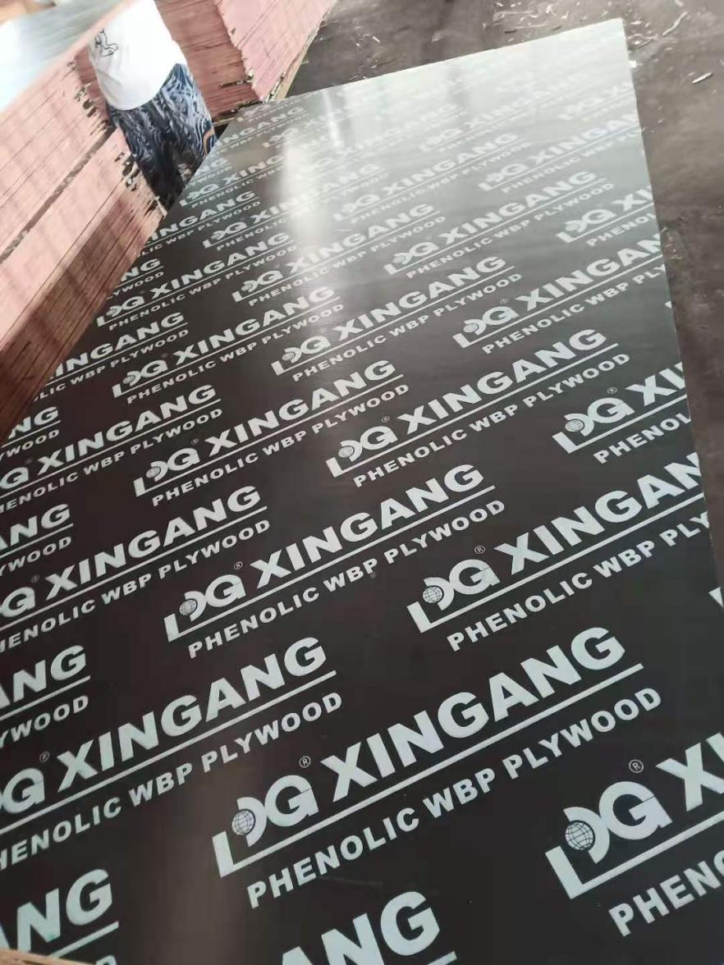
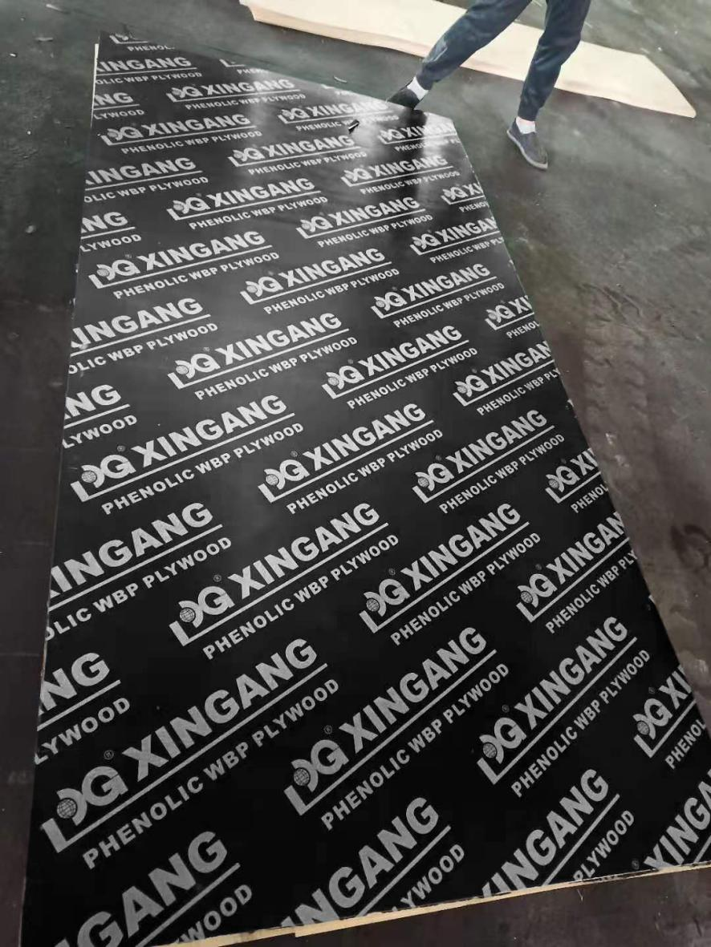

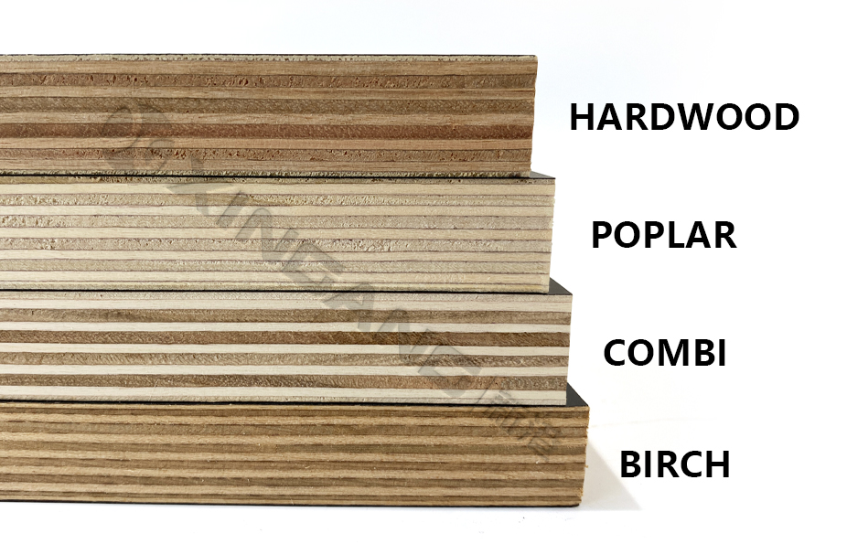

- Quality control:
We have 16 QC teams to inspection such as moisture control, glue inspection both before pro-duction and after production, material grade selection, pressing checking, and thickness che-cking. Our aim is to supply high quality product with reasonable price.

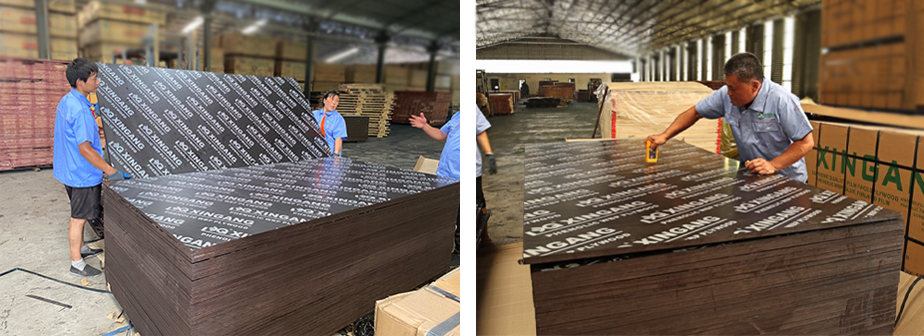

MORE PRODUCTS
- Finger-Jointed Film Faced Plywood
SIZE(MM):915X1830,1220X2440,1500X2500,1200X2400,1250X2500,1500X3000
THICKNESS(MM):9,12,15,18,20,21,24,27,30,35
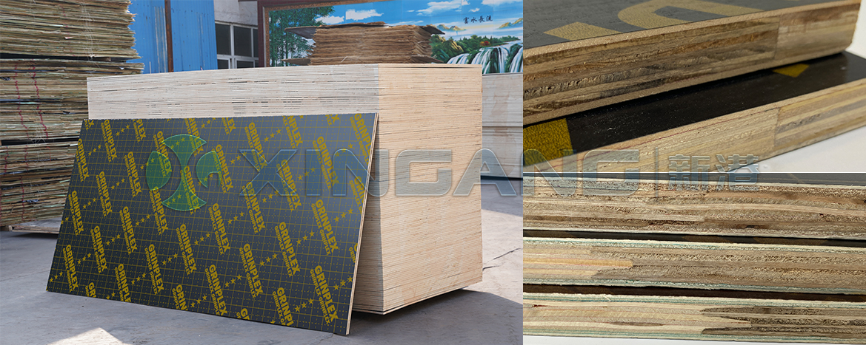

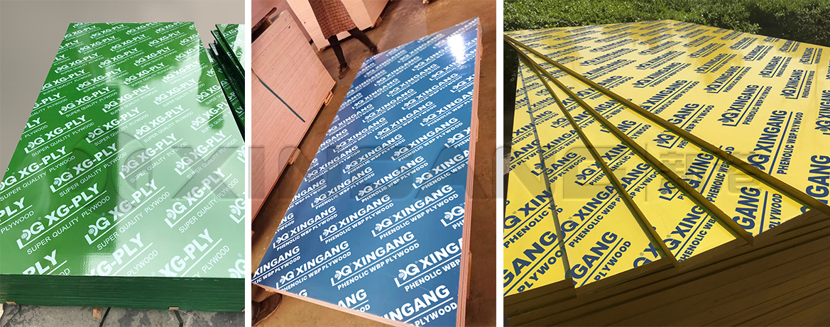
- PP、PVC Plywood
SIZE(MM):915X1830,1220X2440,1500X2500,1200X2400,1250X2500,1500X3000
green pvc film / blue pvc film / yellow pvc film

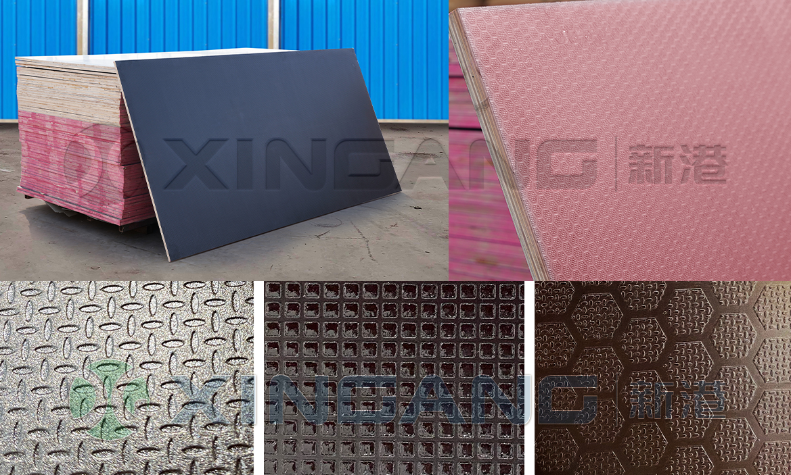
- Anti-slip film faced plywood
COLOR OF SURFACE/FILM:BLACK FILM,BROWN FILM,GREEN PLASTIC FILM
GLUE:WBP MELAMINE,WBP PHENOLIC
CORE : BIRCH,POPLAR,HARDWOOD,PINE,COMBI

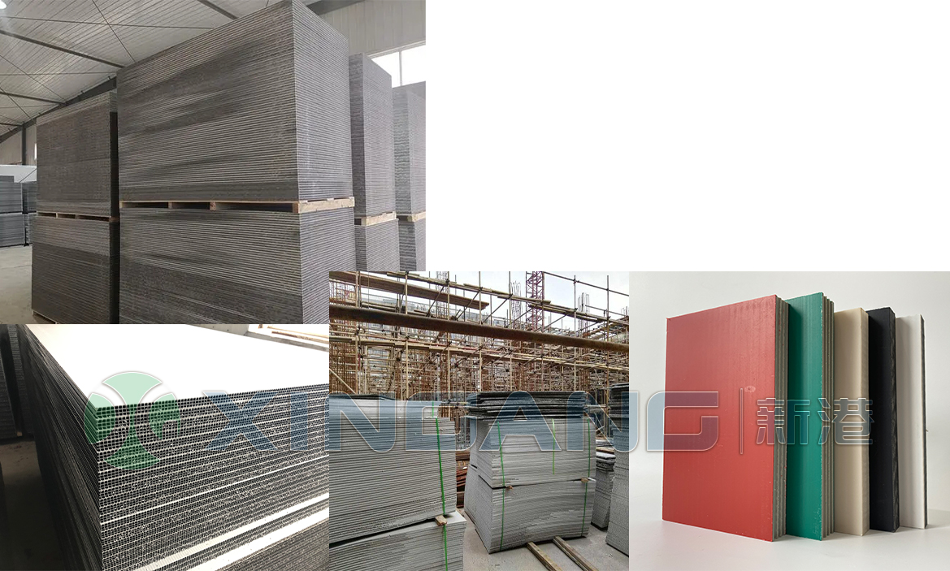
Plastic Plywood
PP,PVC Plywood

To learn more about our products and services, contact us today!

Add:Yitang Town,Lanshan District,Linyi City,Shandong Province,P.R.China
Tel:0086-539-7053333 Fax:086-7052222
Http://www.xingang-wood.com
Email:xingang@cnxingang.cn

